Aim
To design and implement a web-based input form that validates user data such as email and phone number and displays appropriate error messages using HTML, CSS, JavaScript, and Validator.js.

Procedure
- Create Project Files
  - Open VS Code
  - Create a folder and add three files:
index.html, style.css, script.js
- Design the HTML Form
  - Create a form with input fields for email and phone number
  - Add <span> elements below each field to display error messages
  - Link the CSS and JavaScript files
  - Include Validator.js using a CDN link
- Apply Styling using CSS
  - Style the form container, input fields, and button
  - Use .error class to display error messages in red color
- Implement Validation using JavaScript
  - Access input fields using getElementById()
  - Add event listener for form submission
  - Prevent default form submission using event.preventDefault()
- Validate Email Field
  - Check if the email field is empty
  - Use validator.isEmail() to verify correct email format
  - Display error message if invalid
- Validate Phone Number Field
  - Check if phone field is empty
  - Use validator.isMobilePhone() with 'en-IN' for Indian format
  - Display error message if invalid
- Display Success Message
  - If all inputs are valid, show success alert
  - Optionally reset the form
- Run the Program
  - Open index.html using Live Server
  - Test with valid and invalid inputs
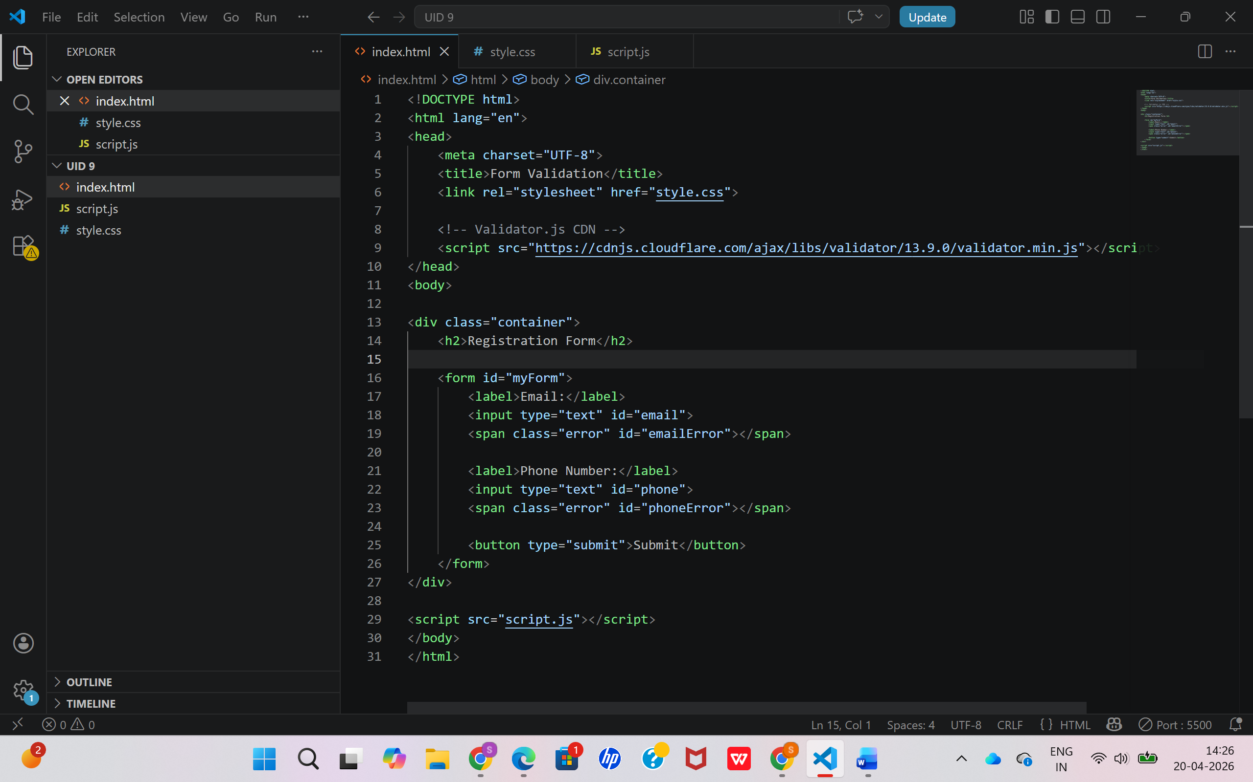

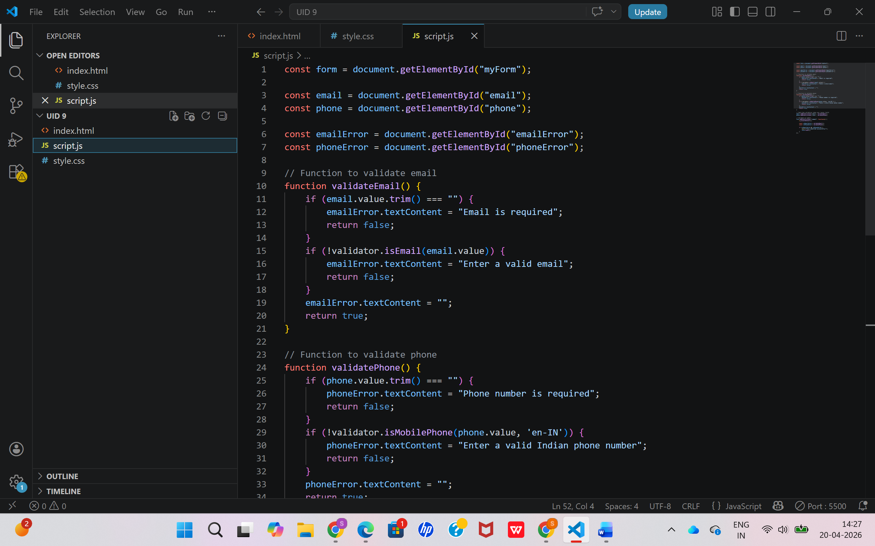

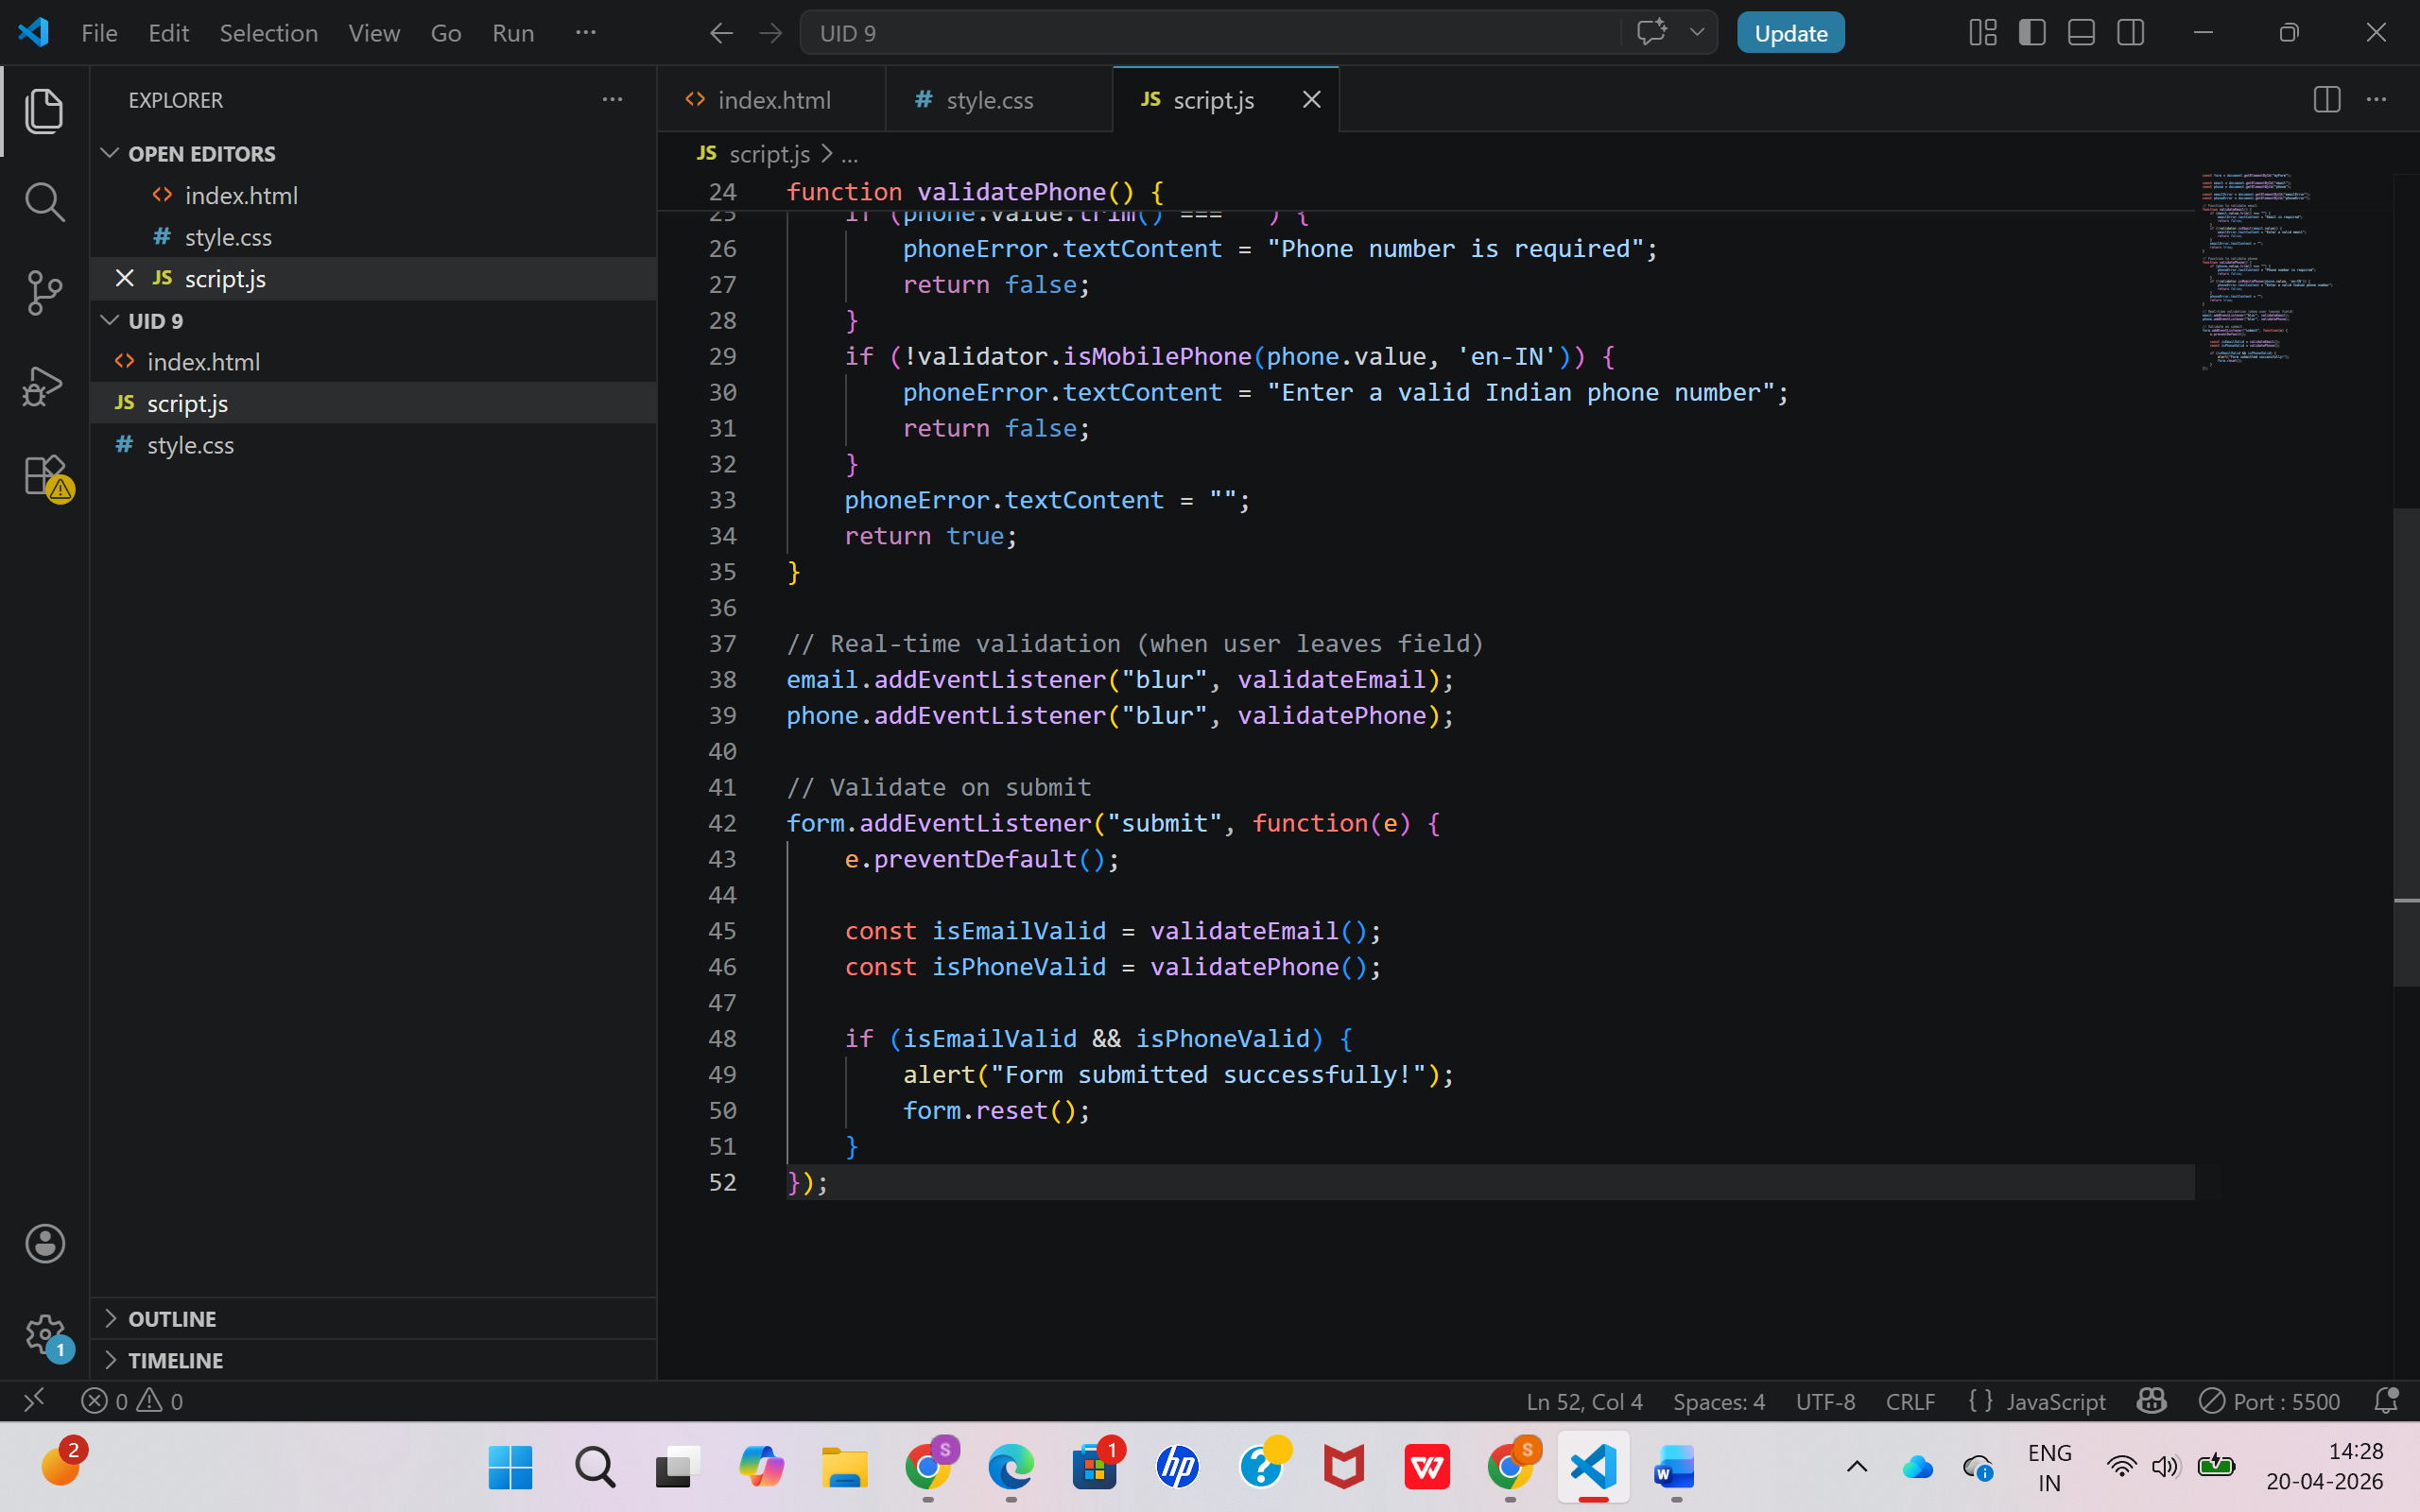

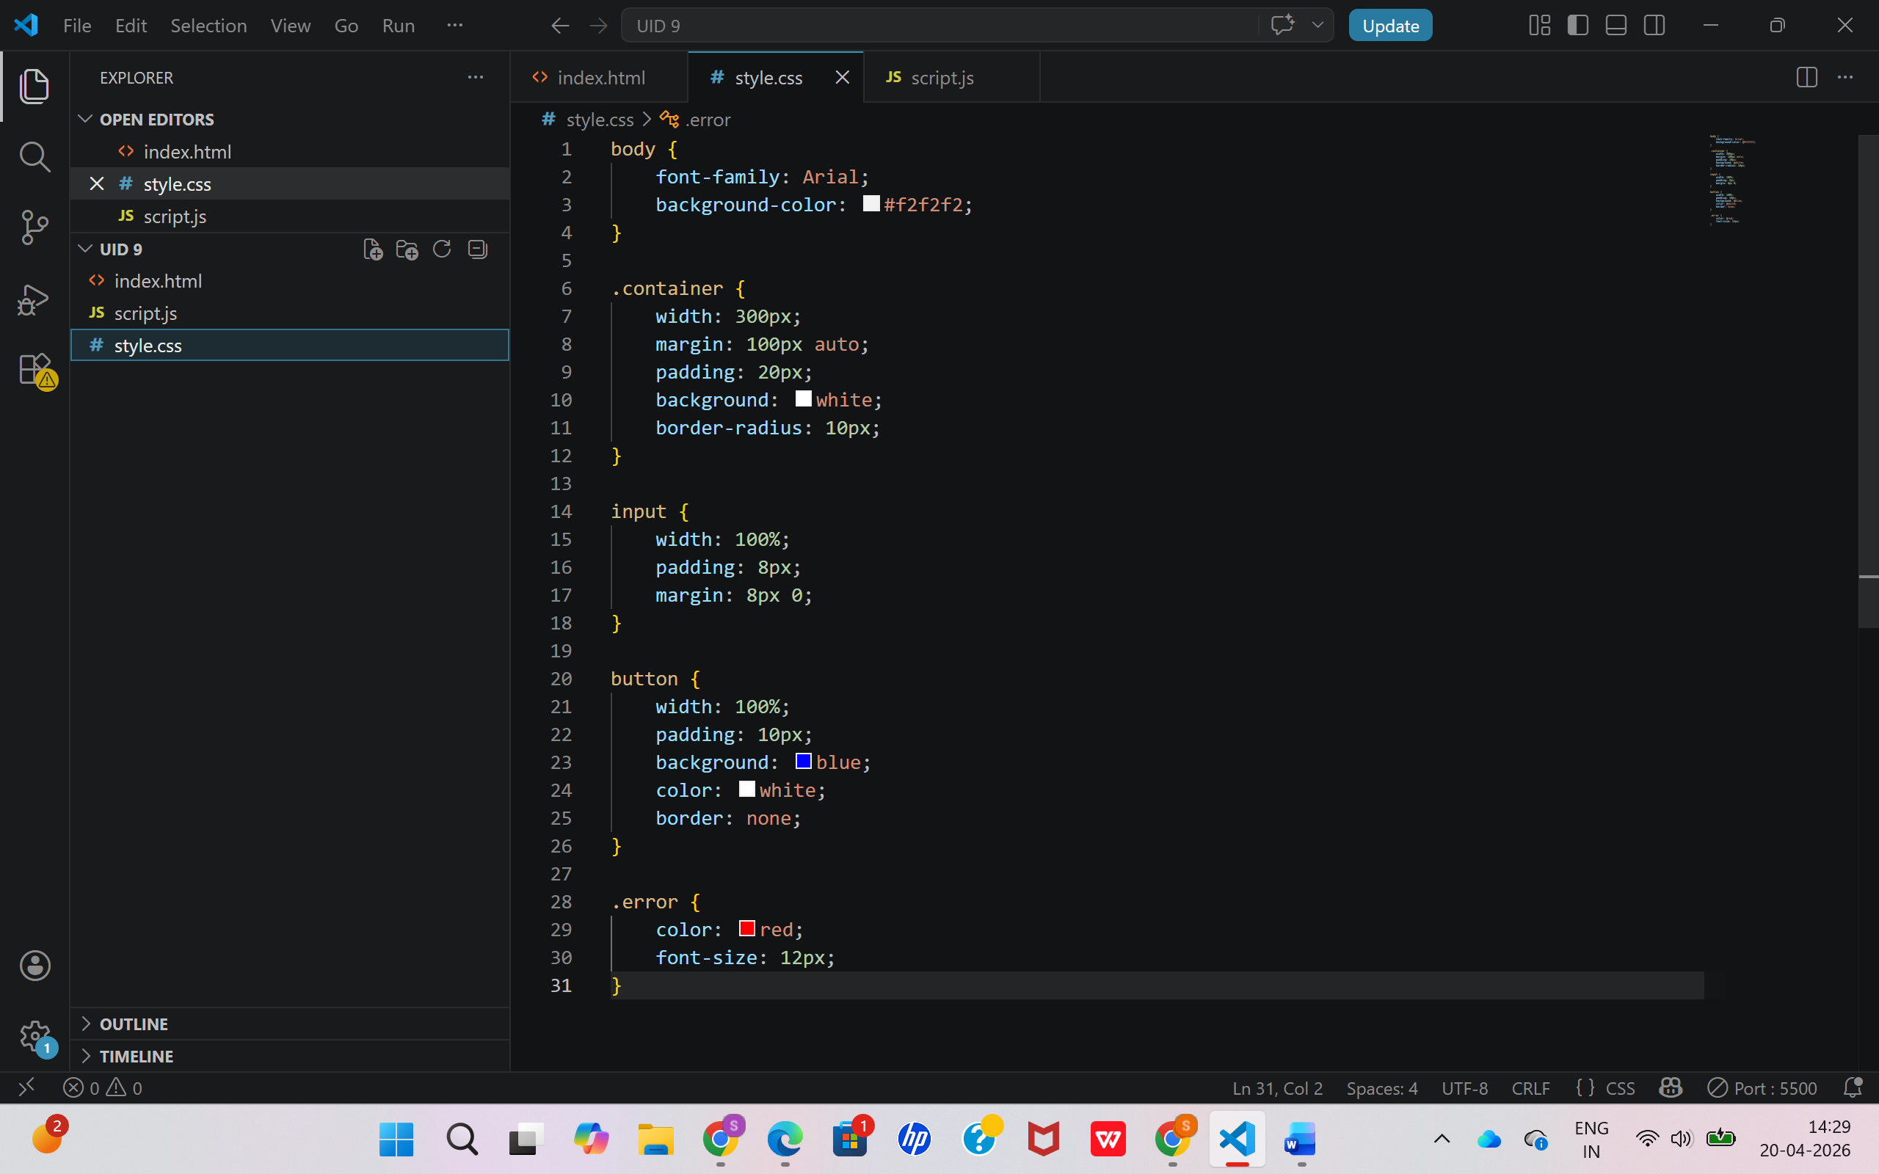

Output
- A web form is displayed with:
  - Email input field
  - Phone number input field
  - Submit button
- When invalid data is entered:
  - Error messages are shown below respective fields
- When valid data is entered:
  - A success message (“Form submitted successfully!”) is displayed
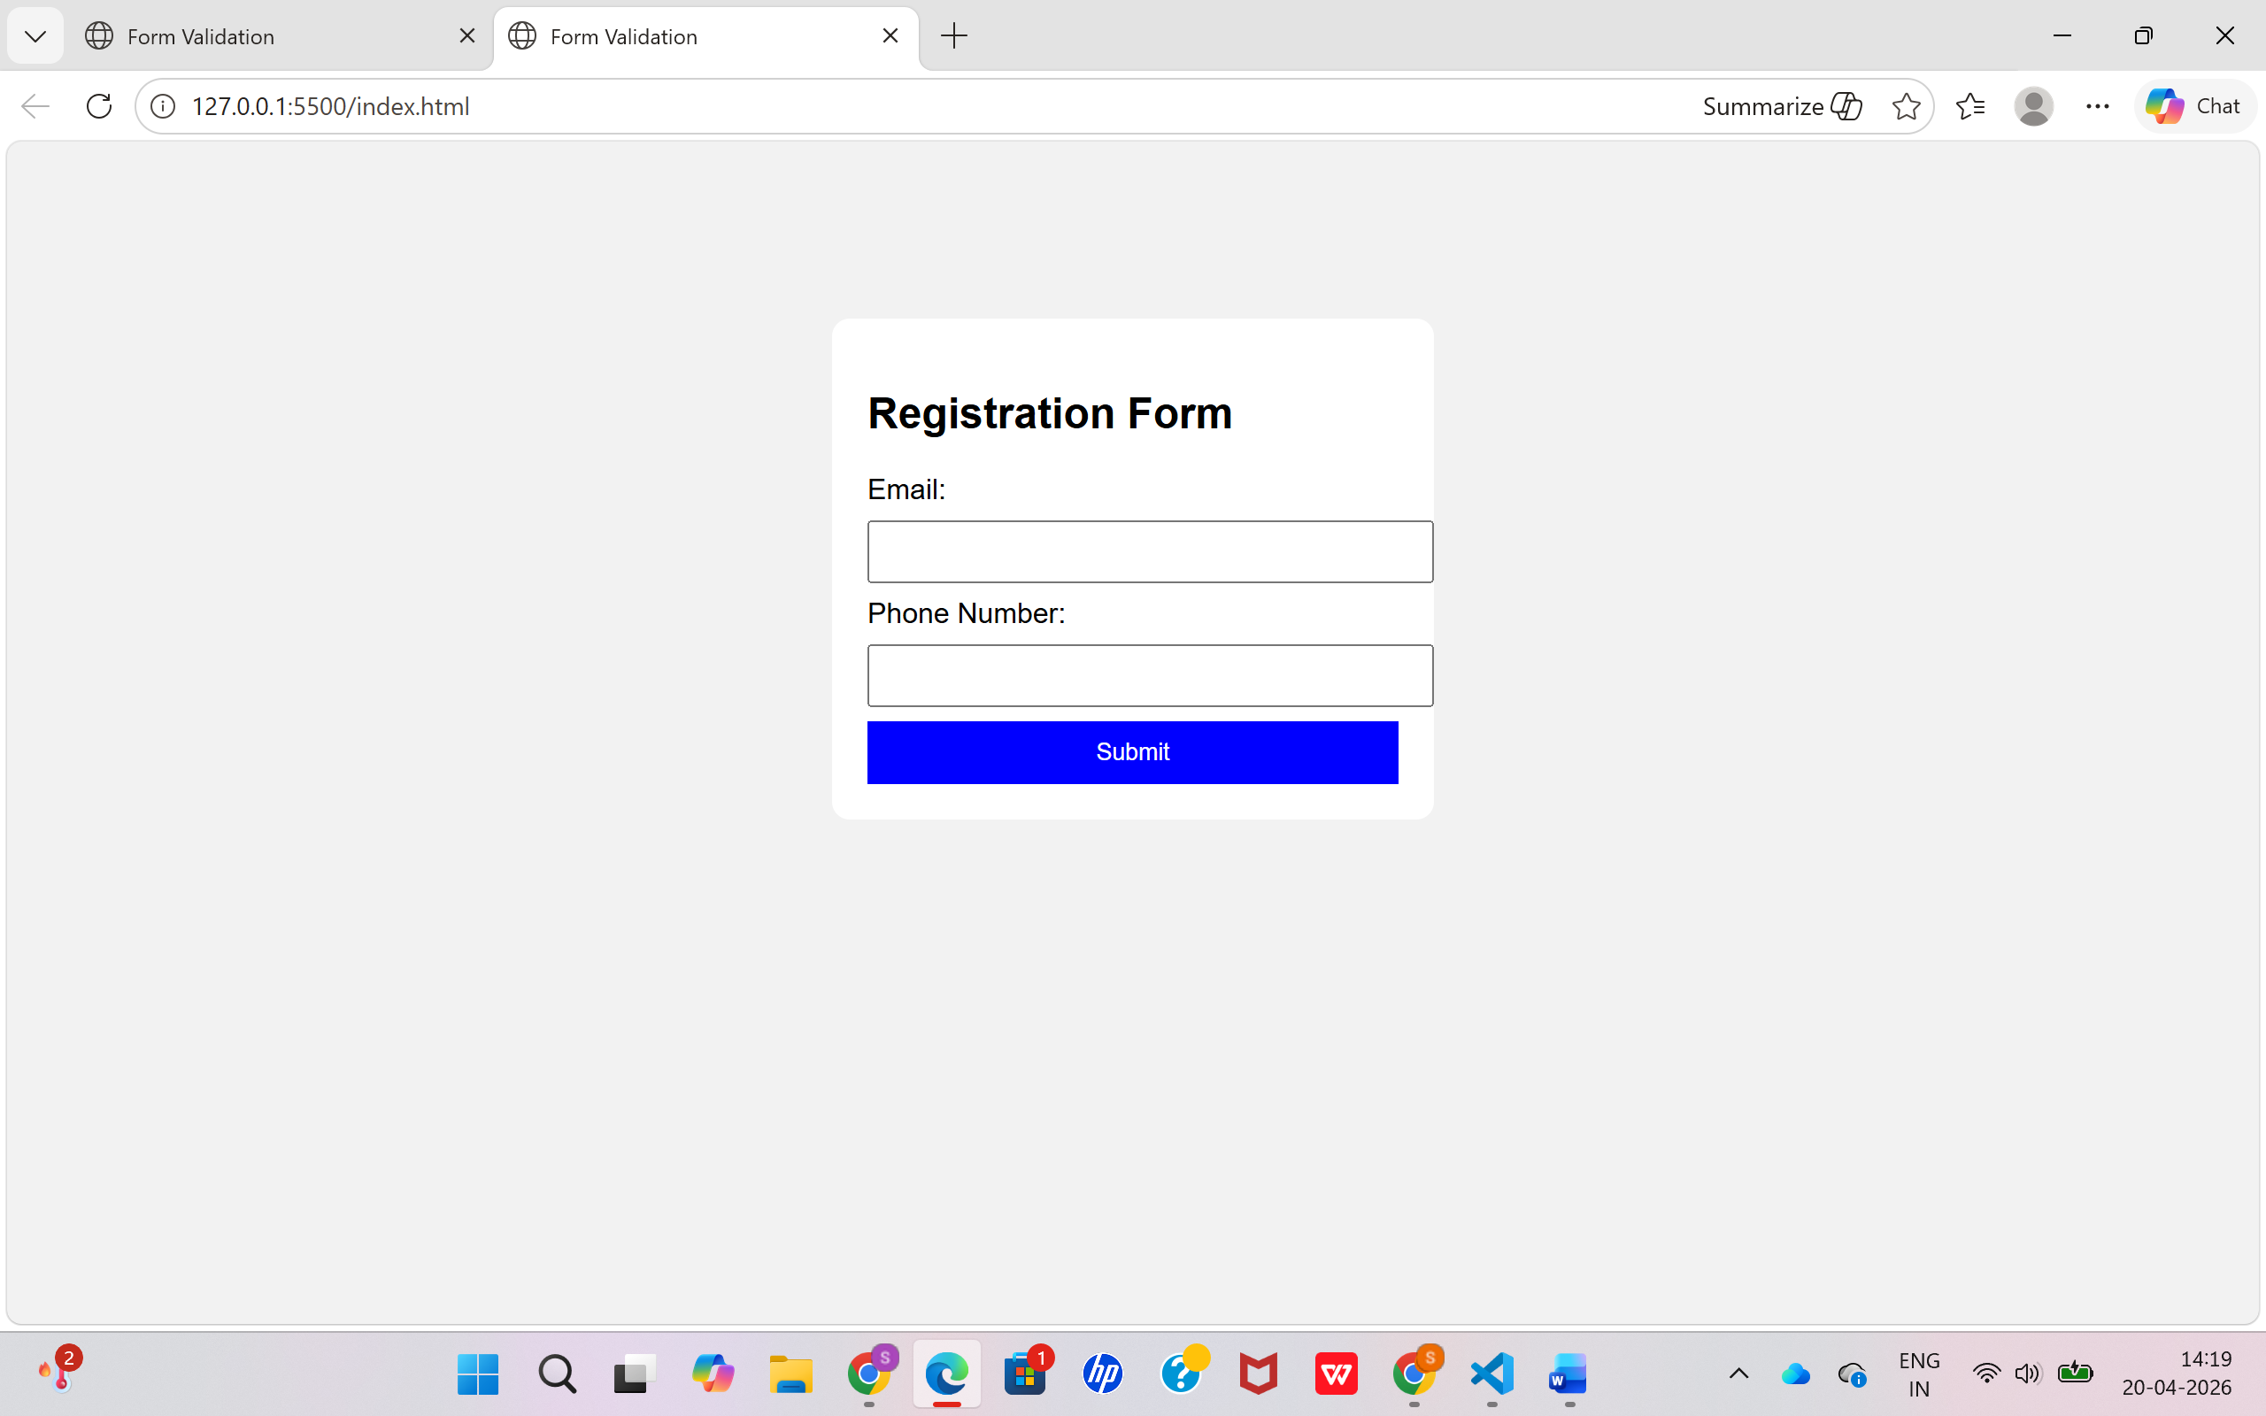

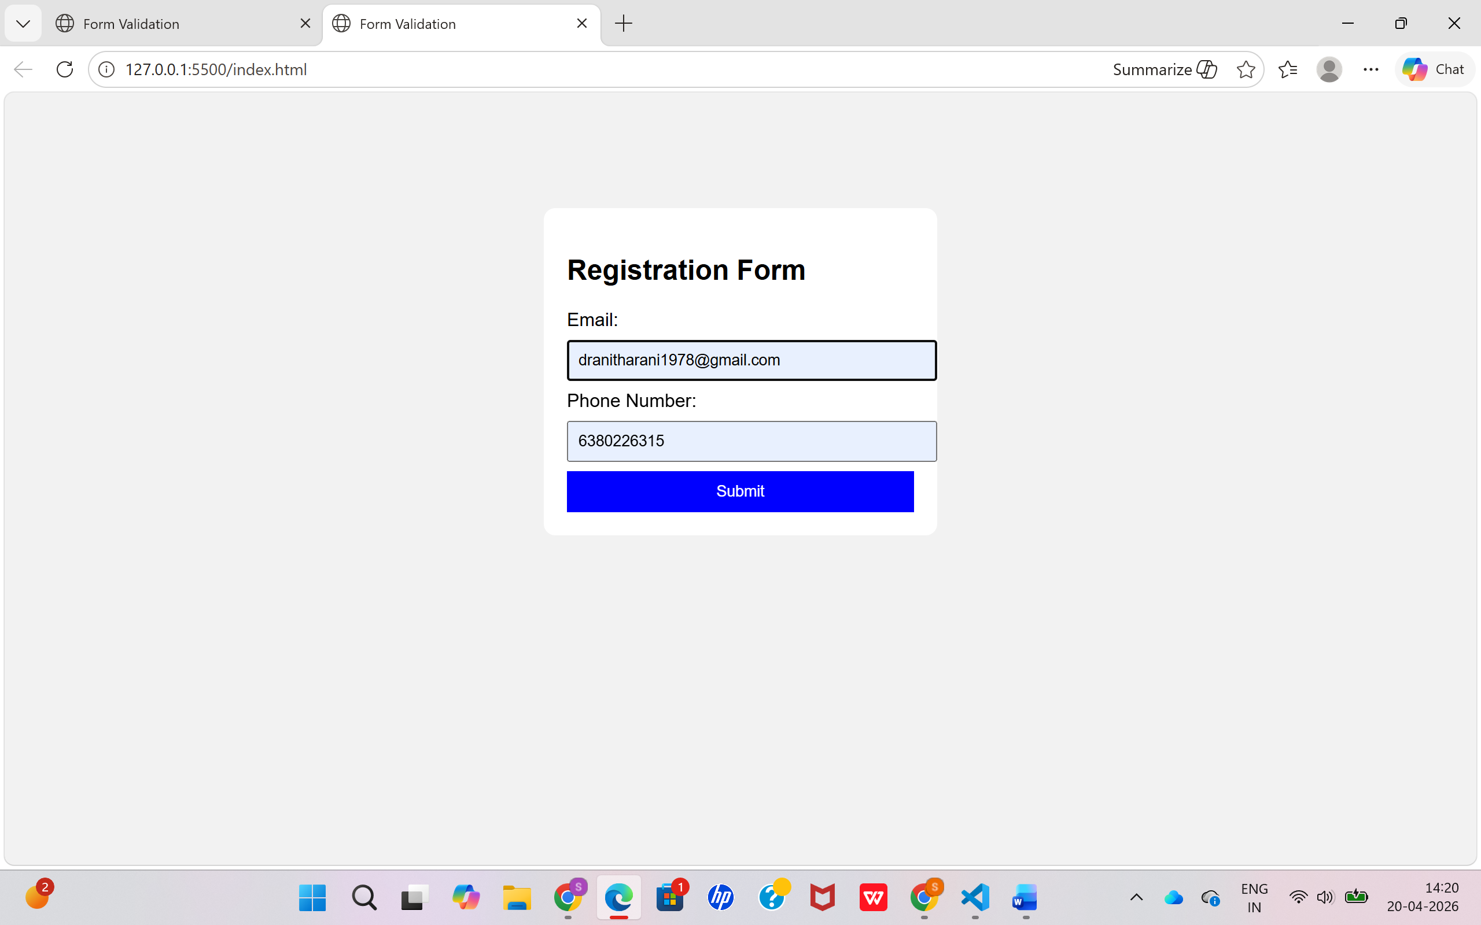

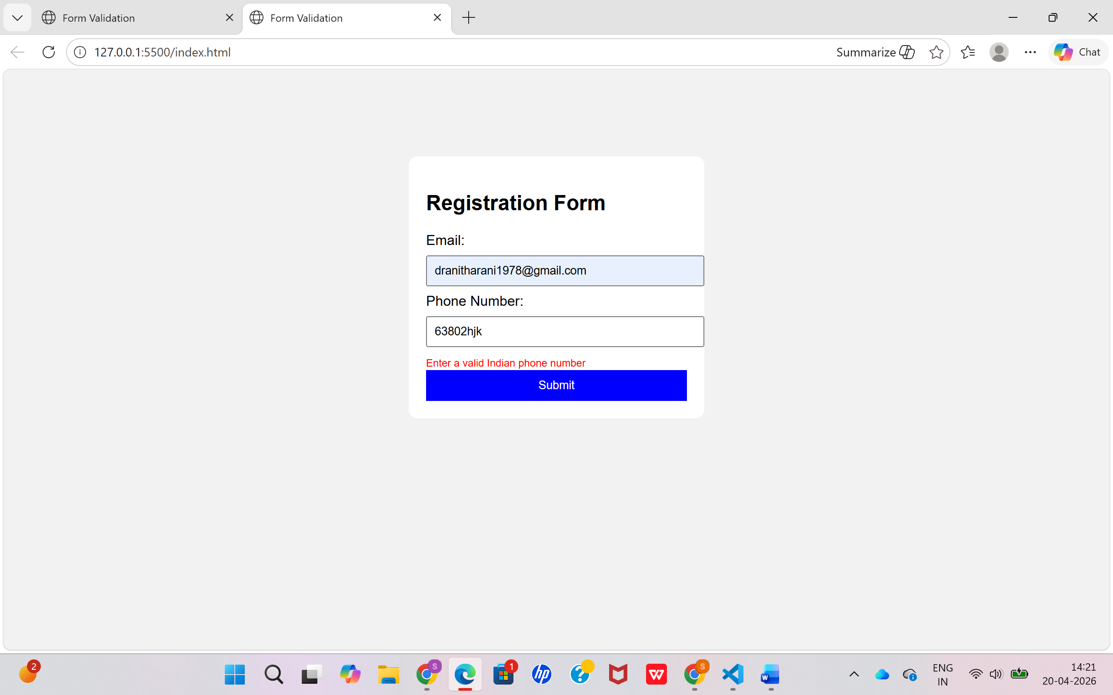

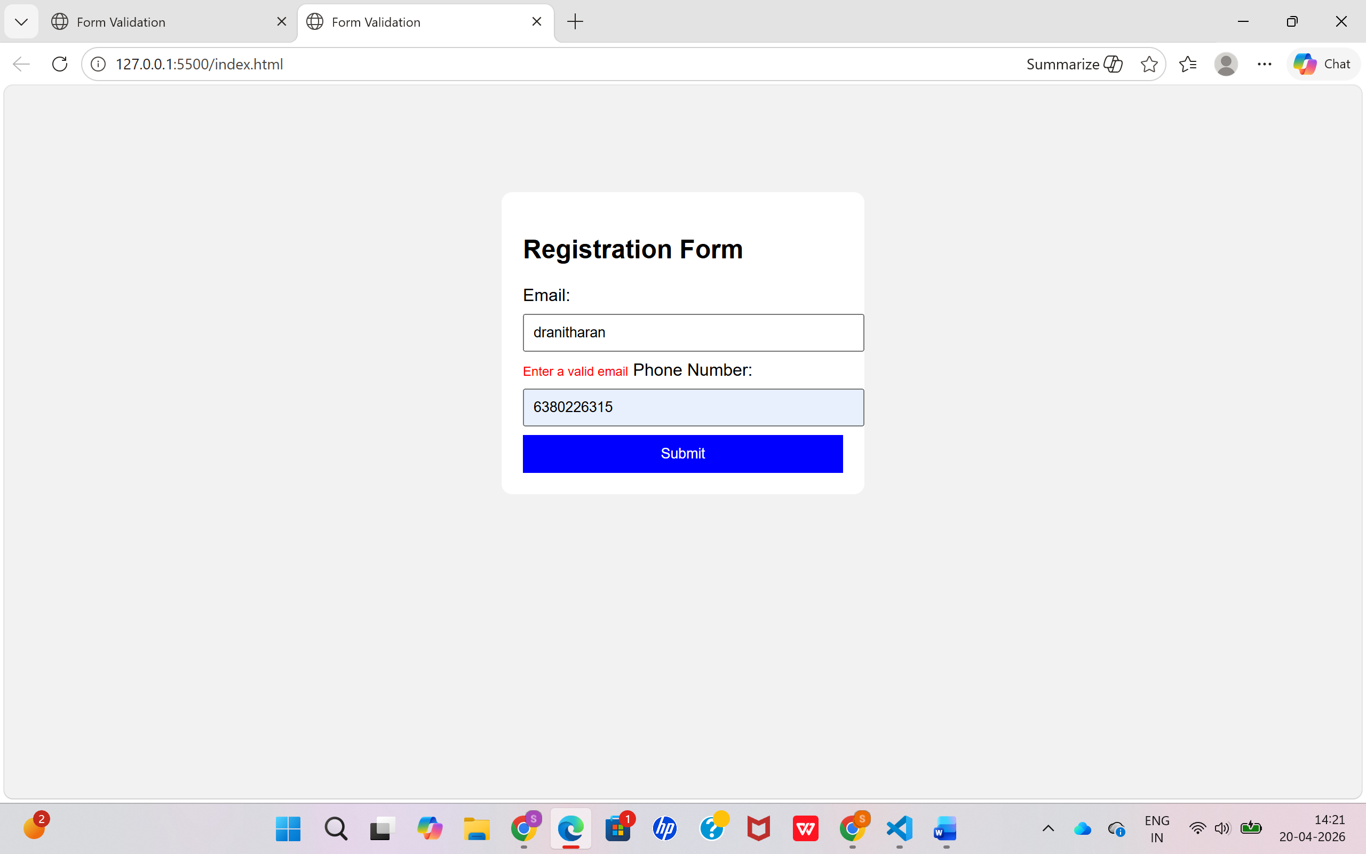

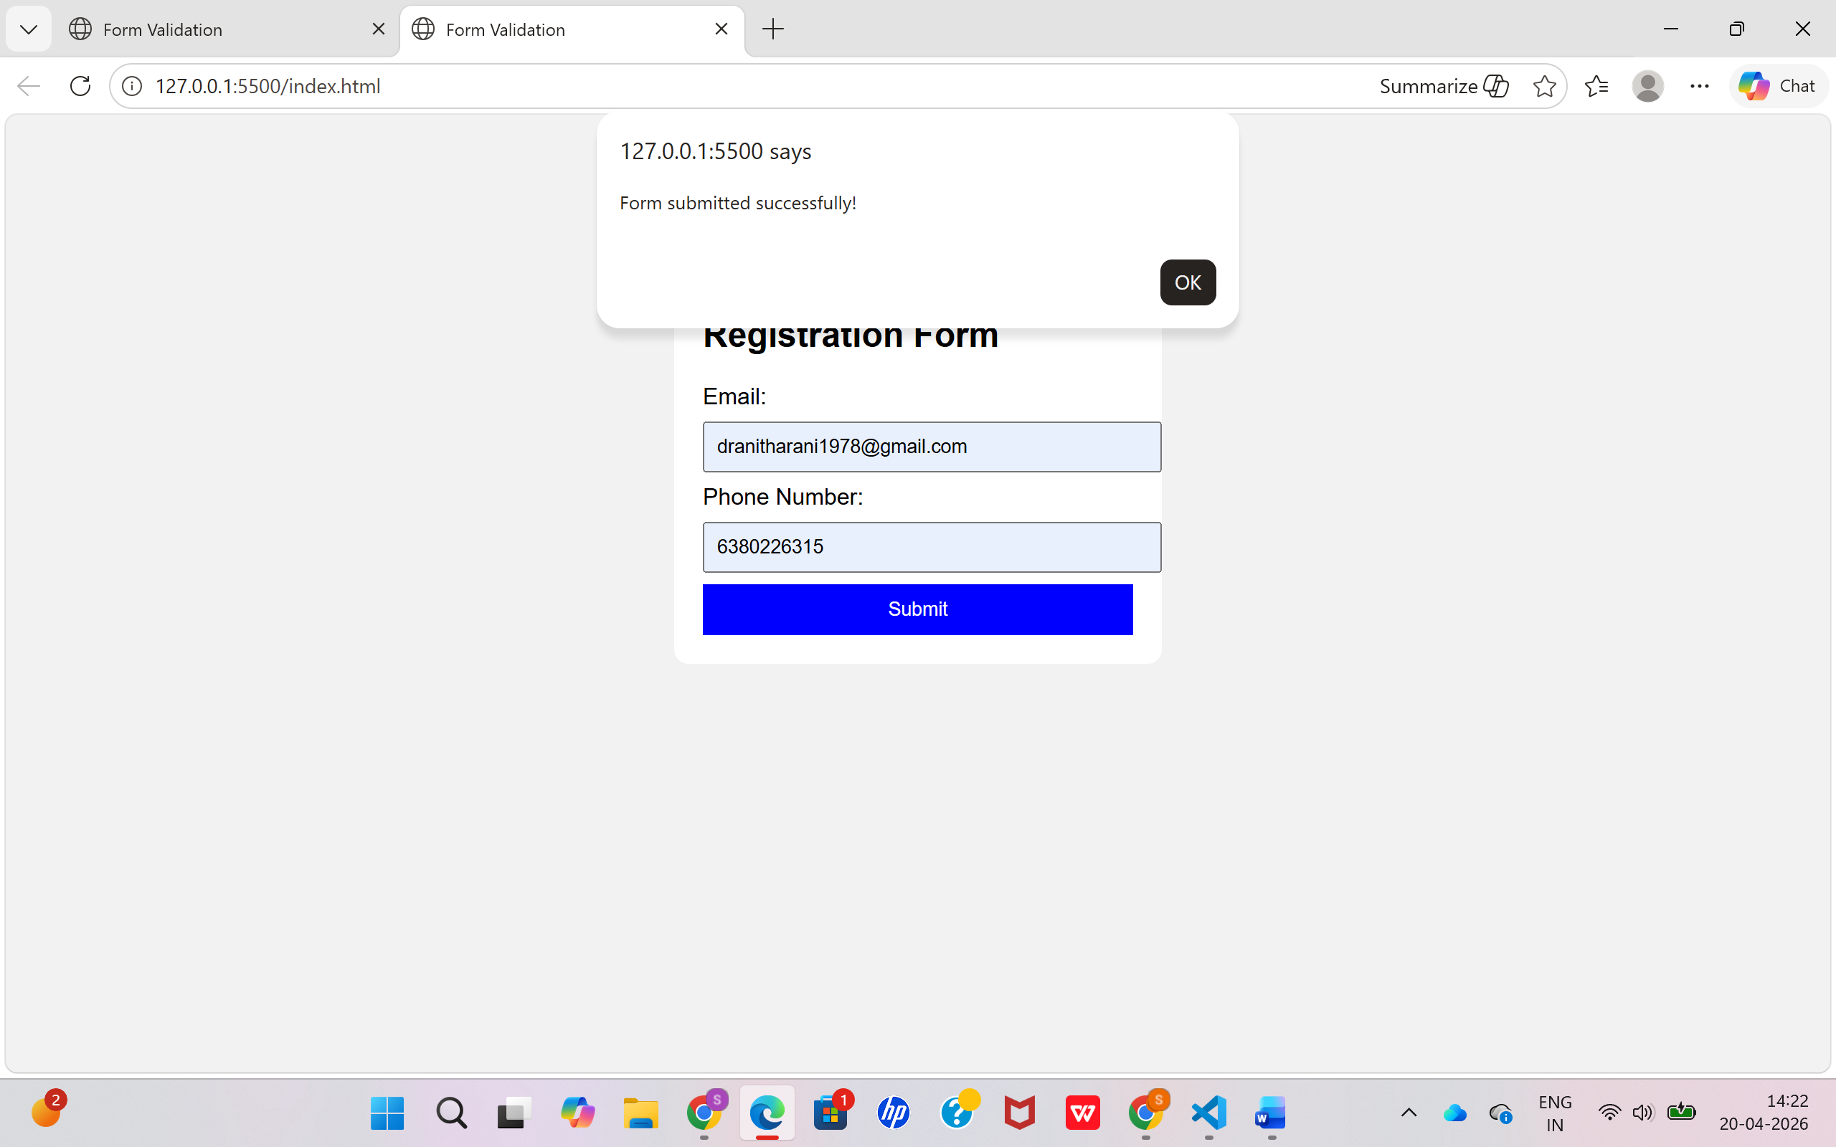

Result
The input form was successfully created and validated using HTML, CSS, JavaScript, and Validator.js. The system correctly identifies invalid email and phone number formats and displays appropriate error messages, ensuring accurate user input before submission.

